Curriculum vitae
- Name:Fayrouz AbdEl Rahman Allam
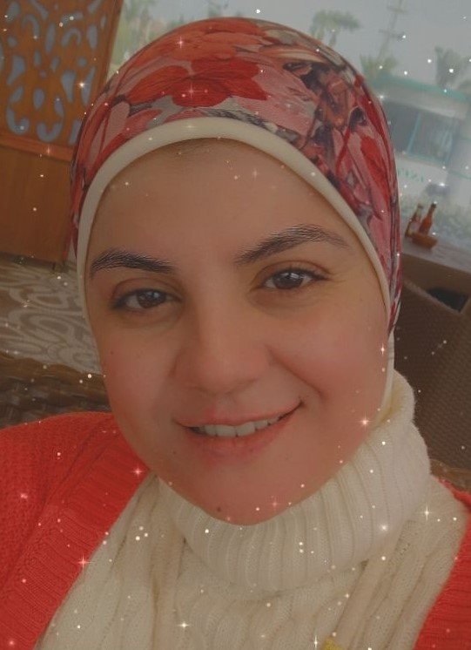
- Date of birth: 9/2/1978
- Nationality:Egyptian
- Phone Number: 01003833712
- E-mail: f_allam2008@yahoo.com,
dr-fayrouz@ tims.gov.eg
- Education& Training:

Institution  [ Date from - Date to ] | Degree(s) or Diploma(s) obtained:
Faculty of Engineering, Helwan Univ.  (2007-2014) | PhD in Computer Engineering (Automatic control)  "closed loop control system for blood glucose regulation for type-1 diabetic patients"
Faculty of Engineering, Helwan Univ.  (2001-2006) | MSc. In digital signal processing  "comparative study on super-resolution of images"
Faculty of Engineering, Helwan Univ.  (1995-2000) | BSc. of Communication And Electronics Engineering
ITI, On-line course  June,2020 | e-learning fundamentals
On-line webinar  Innovety, June 2020 | How to apply 10 innovative principles to revive your products, services &business models
AIDMO-Workshop  11June, 2020 | ITC Leadership in COVID-19
On-line- Egyptian Patent Office-  June,2020 | The workflow of the Egyptian patent office
ASRT  May, 2020 | Applied project management- level1
ASRT  March, 2020 | Strategy Formulation and planning
ASRT  May.2020 | Innovation support law
Elsevier research intelligence  May, 2020 | Selecting a journal for publishing using Scival""
On-line course, almentor,  2020 | Train the trainers, the complete guide
On-line course, almentor,  2020 | Business data analysis using excel
On-line course, almentor,  2020 | Change management in work and life
On-line course, almentor,  2019 | Stress Management
On-line course, almentor,  2019 | Self awareness, your GPS in life
ARAC, August 2019 | Developing the skills of faculty members
March 2019 | Pressure gauge calibration
March 2019 | Calibration of balances
TIMS. 2018 | ISO17025 General Specifications
TIMS 2018 | ISO17025 Internal Auditing
ASRT, 9-10 December, 2018 | Applying for EU H2020 research funding grants
EU ENPI CBC MED Project FOSTER in MED  (15-28 Nov. 2015) | PV certified course for installer
Berlitz  26 Aug.- 12 October. 2015 | English (level7) Berlitz conversation course
National center for research  16-20 Augst. 2015. | Solar Energy Importance and its Practical Application course
13-17 Dec. 2014. | Commercialization and Technology Valuation Course
Helwan Univ.  8Dec. 2014 | How to use internal database for scientific research Course
Innovety company, Nov.2014 | Business strategy
Innovety Company  Nov. 2014 | Technology commercialization,
Innovety Company  Nov. 2014 | Patent information and patent search,
Certificate from WIPO patent office, March, 2017. | "Intellectual Property Rights", Online course at WIPO patent office
Certificate from WIPO patent office , May, 2018. | Patent Drafting
Egyptian Patent Office, 8- 9 Sept.2015 | Patent drafting course
TIMS, 2014 | ISO9001 Internal Auditing
Egyptian association for industrialdevelopment  2-7 March 2002 | Programming of PLC-LOGO
ITC centre (a computer centre authorized from IBM)  (2000-2001) | E-Business diploma (CIW Certification)

- Language skills: Indicate competence on a scale of 1 to 5 (1 - excellent; 5 - basic)
Language | Reading | Speaking | Writing
English | 2 | 3 | 2
Arabic | Native Language

- Other Skills:
-Theory of automatic control teaching.
-PLC Programming (Principles And SIEMENSE Programming).
- Programming using MATLAB.
– Solar Energy design
- Medical Engineering.
- Simulation and Testing of control systems.
- Image processing implementations
- Algorithms design and implementations
- Using Fuzzy logic control.
- using Artificial intelligence
– Patent writing.
-Proposal writing .
- Technology evaluation
- Microsoft office
-Programming using C language
-Electronic cards maintenance
-electrical measuring instruments calibration
- Present Position:
-Lecturer in automatic control department.
- Quality manager in Measurement and Calibration lab, TIMS
- ProfessionalExperience
Date from - Date to | Country | Company Served | Position/Assignment | Description
Feb., 2014 till now | Egypt | Tabbin Institute for Metallurgical Studies (TIMS), | Lecturer in Automatic Control Department | -Teaching in postgraduate diploma  - Teaching automatic control and PLC courses for engineers from industry.
April, 2014 till 2018 | Egypt | TIMS | Deputy director of TISC (technology and innovation support center) in TIMS. | - Increasing the awareness of protecting new ideas and helping in patent drafting.
May., 2005 to Feb. 2014 | Egypt | TIMS | Assistant lecturer in Automatic Control Department | -Teaching PLC courses for engineers from industry.
Feb., 2002 to May, 2006 | Egypt | TIMS | Electronic specialist engineer | -Electronic cards maintenance, programming with visual basic, working with measuring and calibration devices.
2001 to 2002 | Egypt | CITC (IBM computer training center) | Programming Instructor | - E-Business track instructor

12. Courses that have been taught
-Theory of automatic control.
- Measuring devices.
-Information technology.
-testing the designed control system using MATLB
-Programming of Programmable logic control (PLC) (beginner and advanced)..
- Programming of Siemense S7 PLC (beginner and advanced).
- Troubleshooting of PLC.
-Generation of electricity from solar energy
- Programming using PHP.
-Programming using MATLAB.

13. Thesis supervision:
Supervised a thesis titled:” smart grid application in Egyptian electrical transmission network”, 2018.

14. Area of research:
- Automatic control.
- Electrical engineering.
- Automatic control application in Biomedical engineering.

15. List of Publications:

- "Protecting Overhead Transmission Lines (OHL) from Hot Spots Using Dynamic Line Rating (DLR) Calculations", accepted for publication in international conference of electrical engineering (ICEENG-12), 2020.
- “Using IEEE Standard 738 to Increase Rating of Overhead Transmission Line (OHL)”, Saudia Arabia Smart Grid 2019 Conference (SASG2019).
- "An insulin scaling algorithm in a control system based on risk minimization of hypo- and hyperglycemia", ICEENG2018.
- “Blood Glucose Regulation Using a Neural Network Predictor with a Fuzzy Logic Controller”, Journal of Intelligent & Fuzzy Systems, vol. 25, pp. 403–413, 2013.
- “Evaluation of Using a Recurrent Neural Network (RNN) and a Fuzzy Logic Controller (FLC) In Closed Loop System to Regulate Blood Glucose for Type-1 Diabetic Patients”, I.J. Intelligent Systems and Applications, vol. 10, pp. 58-71, 2012.
- “Prediction of Subcutaneous Glucose Concentration for Type-1 Diabetic Patients Using a Feed Forward Neural Network”, International Conference on Computer Engineering & Systems (ICCES’2011), pp. 129-133, 2011.
- “A Recurrent Neural Network Approach for Predicting Glucose Concentration in Type-1 Diabetic Patients”, In proceeding of EANN/AIAI 2011, Part I (IFIP AICT 2011), pp. 254–259, 2011
- Comparative Study on Super-Resolution Of Images, ICEES’2006.
16. Conferences attended:
- 12th International conference of electrical engineering," ICEENG-12", 7-9 July, 2020.
- 9th Egyptian - German Renewables Day, October 2018.
- The International Conference Of Electrical Engineering, 3-5 April, 2018.
- The Fifth Forum for Occupational Safety and Health and Securing the Work Environment, 14 May, 2018.
- 11th International conference of electrical engineering," ICEENG-11", 3-5 April, 2018.
- Science and innovation summit, March 2017
- Future of energy in Egypt, Delphi Survey, Jan. 2017.
- International conference of smart grid, "Africa smart grid forum,2016".
- The international conference of collaboration between industry and academia, 2015
- The international conference of collaboration between industry and academia, 2014.
- The International Conference on Computer Engineering & Systems (ICCES’2011), 2011.
- The 2006 International Conference On Computer Engineering & Systems (ICEES’2006), Ain Shams
17. Reviewed papers:
1. “Congestion Management of Integrated Transmission and Distribution Network with RES and ESS under Stressed Condition.”, International Transactions on Electrical Energy Systems. 2021.
2. “On VMD of Wind Speed for Real-Time Thermal Rating Determination in Power Transmission System." Energy & Environment journal., 2021

